ST GEORGE’S MEDICAL PRACTICE
Yarm Road, Middleton St George, Darlington, DL2 1BY
Tel: 01325 332022
Website: www.stgeorgesmp.co.uk
Email: stgeorges.medical@nhs.net

Welcome to the seventh edition of our newsletter from St George’s Medical Practice.
Surgery Closure
Due to the May Bank Holidays the surgery will be closed on Monday 6th May 2019 and Monday 27th May 2019. If you require urgent medical assistance please telephone 111.
The surgery will also be closed on Wednesday 15th May 2019 from 12pm and will reopen at 8am on Thursday 16th May 2019.
Please note the surgery closes for staff training every Wednesday 12.30-2pm.

Staff Update: Dr Oxley will start her maternity leave on 29th May 2019.

Friends and Family Test
All patients have the opportunity to state how likely they are to recommend our GP practice to friends and family. The information is used for quality monitoring purposes and is also fed back into the practice to enable changes and/or improvements to be made. The responses are anonymous and can be done via the paper copy in the waiting room or online via our website www.stgeorgesmp.co.uk.

NEW – NHS APP
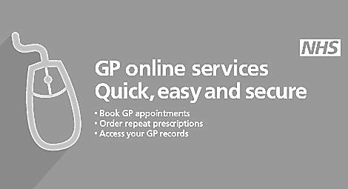
The new NHS app is now available to be downloaded to your mobile phone. Once you have registered with the app you can book/cancel doctors appointments, review any pending appointments, order repeat medication, view your medical record, access a online symptom checker and register for organ donation.
Don’t forget that e-consults are now available within the practice.
Please visit our website at www.stgeorgesmp.co.uk.
E-consults are the new way of consulting with your GP. You don’t need to wait for an appointment to consult your GP, you can now go online and “beat the queue!”
All e-consults are responded to by the end of the next working day meaning you can often get a quicker response time than speaking to the receptionists or booking an appointment.

