ST GEORGE’S MEDICAL PRACTICE
Yarm Road, Middleton St George, Darlington, DL2 1BY
Tel: 01325 332022
Website: www.stgeorgesmp.co.uk
Email: stgeorges.medical@nhs.net

Welcome to the fourth edition of our newsletter from St George’s Medical Practice.
Christmas Period Opening Times
Monday 24th December 2018 (Christmas Eve) – 8am – 6pm
Tuesday 25th December 2018 (Christmas Day) – CLOSED
Wednesday 26th December 2018 (Boxing Day) – CLOSED
Thursday 27th December 2018 – 8am – 6pm
Friday 28th December 2018 – 8am – 6pm
Saturday 29th & Sunday 30th December 2018 - CLOSED
Monday 31st December 2018 (New Year’s Eve) – 8am – 6pm
Tuesday 1st January 2019 (New Year’s Day) – CLOSED
Wednesday 2nd January 2019 – 8am – 6pm

Friends and Family Test
All patients have the opportunity to state how likely they are to recommend our GP practice to friends and family. The information is used for quality monitoring purposes and is also fed back into the practice to enable changes and/or improvements to be made. The responses are anonymous and can be done via the paper copy in the waiting room or online via our website www.stgeorgesmp.co.uk.
Don’t forget that e-consults are now available within the practice.
Please visit our website at www.stgeorgesmp.co.uk.
E-consults are the new way of consulting with your GP. You don’t need to wait for an appointment to consult your GP, you can now go online and “beat the queue!”
All e-consults are responded to by the end of the next working day meaning you can often get a quicker response time than speaking to the receptionists or booking an appointment.
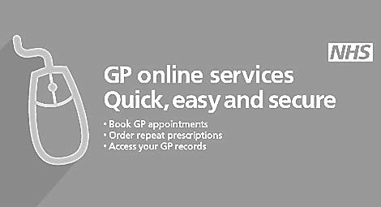
If you are yet to have your annual flu vaccination, please contact the surgery on 01325 332022 to arrange an appointment.

