ST GEORGE’S MEDICAL PRACTICE
Yarm Road, Middleton St George, Darlington, DL2 1BY
Tel: 01325 332022
Website: www.stgeorgesmp.co.uk
Email: stgeorges.medical@nhs.net

Welcome to the sixth edition of our newsletter from St George’s Medical Practice.
Staff Update
Doctors: Congratulations to Dr Oxley on her pregnancy, Dr Oxley will start her maternity leave in May.

Nursing Team: Sadly Sharon Jackson, Nurse Practitioner has now left the practice for pastures new. We wish her well for the future. We are however delighted to be welcoming to the team Helen Parry, Practice Nurse who will be starting with us at the end of March 2019.

Friends and Family Test
All patients have the opportunity to state how likely they are to recommend our GP practice to friends and family. The information is used for quality monitoring purposes and is also fed back into the practice to enable changes and/or improvements to be made. The responses are anonymous and can be done via the paper copy in the waiting room or online via our website www.stgeorgesmp.co.uk.

Thank you to everyone who completed our recent patient survey. The results will be published in the near future.
Don’t forget that e-consults are now available within the practice.
Please visit our website at www.stgeorgesmp.co.uk.
E-consults are the new way of consulting with your GP. You don’t need to wait for an appointment to consult your GP, you can now go online and “beat the queue!”
All e-consults are responded to by the end of the next working day meaning you can often get a quicker response time than speaking to the receptionists or booking an appointment.
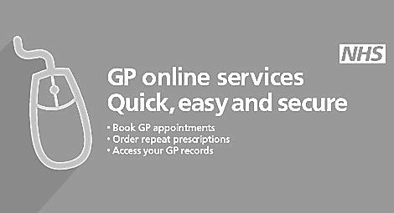
EASTER
The surgery will be closed from Friday 19th April and reopen on Tuesday 23rd April. Please allow extra time when ordering your prescriptions. If you require urgent medical attention during this time please call 111.

