County Durham and Darlington Diabetes Service - Key Messages for June 2018
Stressed Out…………….

Did you know being overly stressed can have an impact on blood sugar levels? Check out these top tips to help you reduce stress levels:

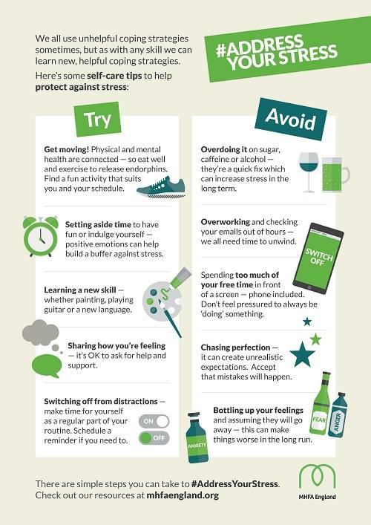
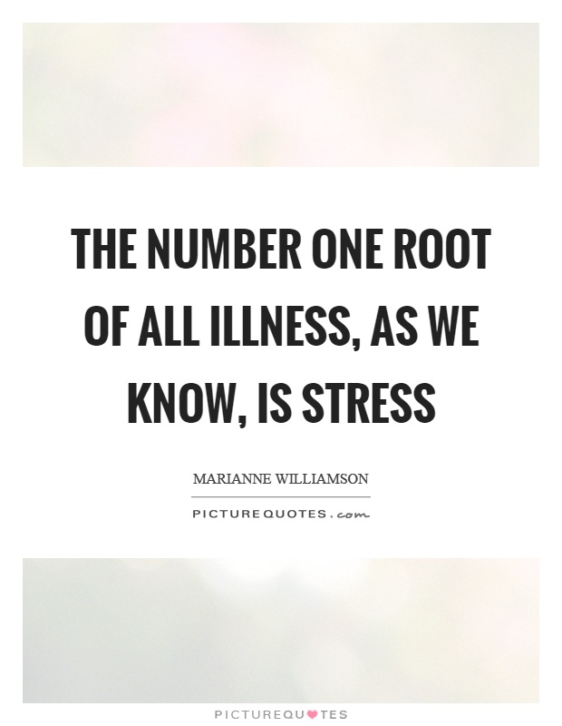
Knowing what makes you stressed, and being able to manage these factors can help to control your diabetes, as well as improving your mental health.
Diagnosis of diabetes?

An HbA1c test can identify people with prediabetes and diabetes. Everyone with diabetes in the UK should be offered an HbA1c test at least once a year. | Normal | Pre-diabetic | Diabetic
HbA1c | < 42mmol/l | 42-47mmol/l | 48> mmol/l
This test is important as the higher the HbA1c, the greater the risk of developing diabetes-related complications. Know your results, take control and reduce the risks! For more information see:
https://www.diabetes.org.uk/guide-to-diabetes/managing-your-diabetes/hba1c
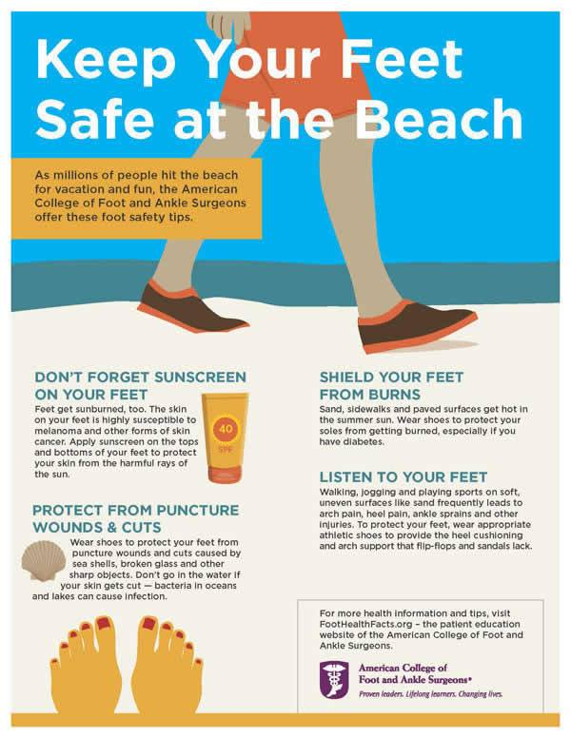
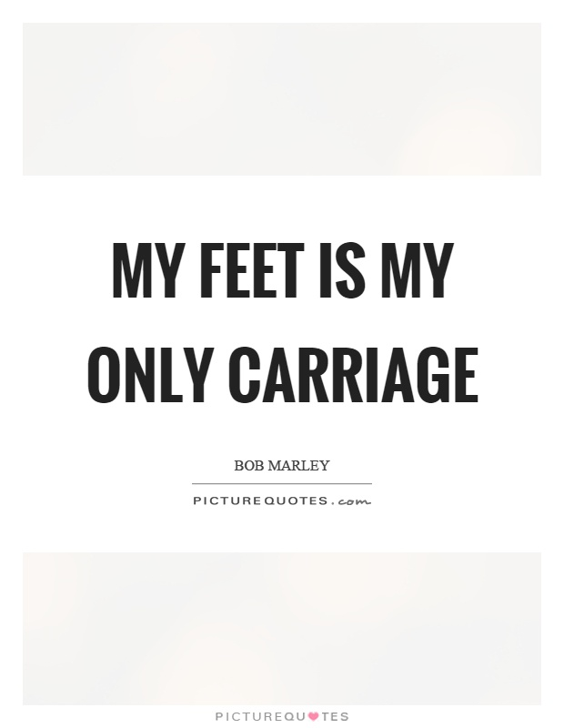
With holiday season approaching it is so important that those with diabetes take care of their feet. Cuts, blisters and burns can become dangerous so check them regularly and avoid walking around barefoot...no matter how appealing the sand looks. Check your feet regularly see this video below to help you: https://www.youtube.com/watch?v=jC9hXPURsQA

Holiday Chill Out
Self-management Course

If you have been diagnosed with Type 2 diabetes and would like information and advice on managing your condition ask your GP or nurse to refer you for a structured education self-management course. This is either one full day or a 2 hour sessions weekly over 6 weeks.

Courses give you information and advice on making healthy lifestyle choices to help you to manage your diabetes. It also gives you the chance to meet other people with diabetes who can help give you support.

For information on how to be booked onto a course please contact us on - 0191 5692848.
We are now on Twitter and Facebook!
@cddftdiabetes and CDDFT Diabetes, patients and healthcare professionals can like and follow us to keep up to date with the latest diabetes news and events.

