County Durham and Darlington Diabetes Service –
Key Messages for October-November 2018
World Diabetes Day 14th November 2018

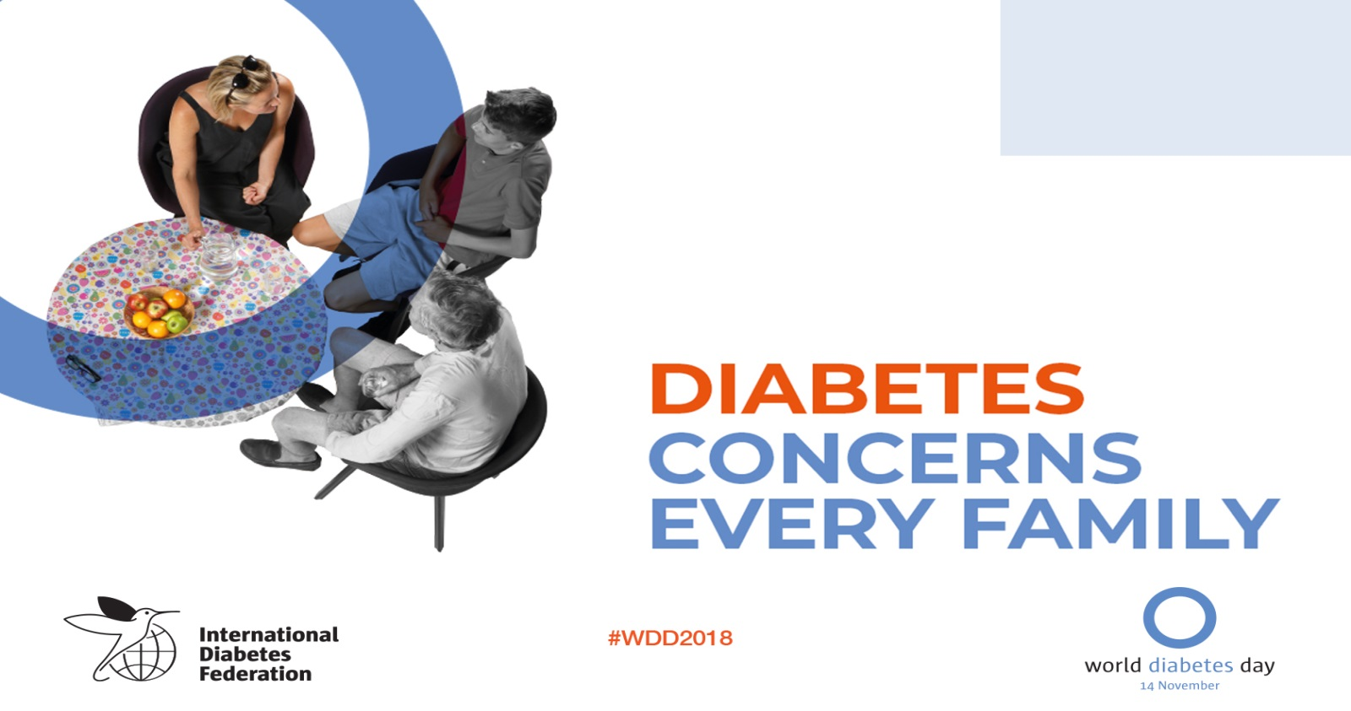
1 in 11 people live with diabetes. 80 % of type 2 diabetes is preventable through adopting a healthy lifestyle.

Preventing type 2 diabetes involves the family too
- Many cases of type 2 diabetes can be prevented by adopting a healthy lifestyle. Reducing your family’s risks starts at home.
- When a family eats healthy meals and exercises together, all family members benefit and encourage behaviours that could help prevent type 2 diabetes in the family.
- If you have diabetes in your family, learn about the risks, the warning signs to look out for and what you can do to prevent diabetes and its complications.
- Families need to live in an environment that supports healthy lifestyles and helps them to prevent type 2 diabetes.

Caring for my diabetes involves my family too
- Managing diabetes requires daily treatment, regular monitoring, a healthy lifestyle and ongoing education. Family support is key.
- 1 in 2 people with diabetes remain undiagnosed; here are some signs to look out for :
  - Feeling tired
  - Feeling thirsty
  - Needing to urinate more often
  - Infections not clearing up as quickly as normal

It can be a shock for family members to find out someone close to them has diabetes as highlighted in this quote
“Finding out that mum had diabetes was a shock for everyone. We were naturally concerned of how diabetes would affect her health long-term, but I am so proud of the way she has taken on the challenge of changing her lifestyle and diet for the better. She is an inspiration to me and inspires me to also look after my own health better”
Family can support making changes by learning about diabetes and how best to manage this condition.

There will be local events happening around World Diabetes Day – follow our social media for details.

Self-Management Course

If you have been diagnosed with Type 2 diabetes and would like information and advice on managing your condition ask your GP or nurse to refer you for a structured education self-management course. This is either one full day or 2 hour sessions weekly over 6 weeks.

Courses give you information and advice on making healthy lifestyle choices to help you to manage your diabetes. It also gives you the chance to meet other people with diabetes who can help give you support.
For information on the courses please contact us on - 0191 5692848 or to be booked onto a course ask your GP to refer you.

We are now on Twitter and Facebook!
@cddftdiabetes and CDDFT Diabetes, patients and healthcare professionals can like and follow us to keep up to date with the latest diabetes news and events.

