ST GEORGE’S MEDICAL PRACTICE
Yarm Road, Middleton St George, Darlington, DL2 1BY
Tel: 01325 332022
Website: www.stgeorgesmp.co.uk
Email: stgeorges.medical@nhs.net

Welcome to the Eleventh edition of our newsletter from St George’s Medical Practice and Happy New Year!
SURGERY CLOSURE
The Surgery will be closed for Staff Training on Tuesday 14th January 2020 from 12pm and will reopen at 8am the following day.
Please note the surgery closes for staff training every Wednesday 12.30-2pm.

DISPENSARY CLOSURE
As you may already be aware the Practice’s dispensary closed on 31st December 2019, all affected patients should have received written notification of the closure. Any dispensing patients who have not yet collected their repeat prescriptons should contact the surgery as soon as possible. Please be advised that if you require an injection to be administered by the nurse (does not include travel, child or flu vaccinations) you will be asked to collect this from the pharmacy prior to your appointment in future.
NHS APP
Have you downloaded the NHS App yet?

Benefits of the App include: Book and manage your Practice appointments, Order repeat prescriptions, Securely view your GP medical record, Check your symptoms using the health A-Z on the NHS website, Find out what to do if you need help urgently using 111 online, Register as an organ donor and choose whether the NHS uses your data for research and planning.
Don’t Delay and Download Today!

FAILURE TO ATTEND
We average around 80 appointments every month where patients do not attend. If you are unable attend please respond to the reminder text with CANCEL or telephone the surgery as soon as possible on 01325 332022 so that we can offer your appointment to somebody else. Persistent failure to attends may result in a warning letter.
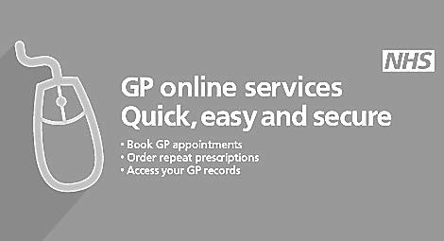
Have you had your flu vaccination?
You can now book your flu vaccine if you are aged 65 and over, have a chronic long-term health condition (those eligible will have been contacted by letter/text) or are aged between 2 and 3 years old.

