ST GEORGE’S MEDICAL PRACTICE
Yarm Road, Middleton St George, Darlington, DL2 1BY
Tel: 01325 332022
Website: www.stgeorgesmp.co.uk
Email: stgeorges.medical@nhs.net

Welcome to the fifth edition of our newsletter from St George’s Medical Practice.
We are now a Parkrun Practice!
WALK, JOG, RUN, VOLUNTEER or simply come and watch – it’s up to you!
Join us on Saturday Mornings at Darlington South-Park Park Run.
Please visit www.parkrun.org.uk for more information.

We would love to hear what you think about our practice and would be very grateful if you could fill out our 2019 practice survey.
Please visit our website to complete the survey. The survey is alternatively available from reception.
Please be assured all responses are anonymous.

Friends and Family Test
All patients have the opportunity to state how likely they are to recommend our GP practice to friends and family. The information is used for quality monitoring purposes and is also fed back into the practice to enable changes and/or improvements to be made. The responses are anonymous and can be done via the paper copy in the waiting room or online via our website www.stgeorgesmp.co.uk.
Don’t forget that e-consults are now available within the practice.
Please visit our website at www.stgeorgesmp.co.uk.
E-consults are the new way of consulting with your GP. You don’t need to wait for an appointment to consult your GP, you can now go online and “beat the queue!”
All e-consults are responded to by the end of the next working day meaning you can often get a quicker response time than speaking to the receptionists or booking an appointment.
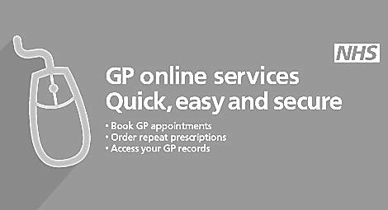
If you are yet to have your annual flu vaccination, please contact the surgery on 01325 332022 to arrange an appointment.

