ST GEORGE’S MEDICAL PRACTICE
Yarm Road, Middleton St George, Darlington, DL2 1BY
Tel: 01325 332022
Website: www.stgeorgesmp.co.uk
Email: stgeorges.medical@nhs.net

Welcome to the third edition of our newsletter from St George’s Medical Practice.
Just a reminder that the practice is closed on Wednesday lunch times from 12:30 – 2pm.
St George’s Medical Practice would like to introduce you to three new members of our team. Our new GP – Dr Abhishek Singh, became a member of our team at the start of August, our new Practice Nurse; Gemma, starts her role with us at the end of September, and Jasmine will be starting at the end of September too as part of the Dispensary team.
Friends and Family Test
All patients have the opportunity to state how likely they are to recommend our GP practice to friends and family. The information is used for quality monitoring purposes and is also fed back into the practice to enable changes and/or improvements to be made. The responses are anonymous and can be done via the paper copy in the waiting room or online via our website www.stgeorgesmp.co.uk.
We are excited to announce that e-Consults have now launched for our patients. The service can be accessed via the practice website and will enable patients to access safe and efficient advice for their health conditions and consult with the GP from the convenience of their own home. E-Consult provides medical advice at the click of a button. Please visit our practice website at www.stgeorgesmp.co.uk and click the link that states contact our doctors online. Here you will be able to learn more about your condition and contact your GP via a form. This will allow the GP to decide upon the most appropriate treatment options for you and you will receive a response by the end of the next working day. You will also be able to request test results and extensions to fit notes.

Since July we have raised another £200 from our book donations for St Teresa’s Hospice. Thank you to everyone who has donated or bought a book. Books are still for sale but we are no longer taking new stock in.

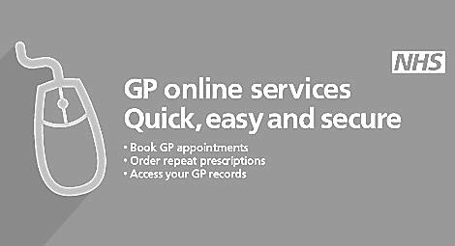
We now have clinics set up for annual flu vaccinations, starting from Monday 17th September 2018. There are appointments available online for patients aged over 75. Alternatively, please contact reception to book your appointment.
Just a reminder that GP Online Services are available within the practice,
please visit our website to sign up to this service.

