ST GEORGE’S MEDICAL PRACTICE
Yarm Road, Middleton St George, Darlington, DL2 1BY
Tel: 01325 332022
Website: www.stgeorgesmp.co.uk
Email: stgeorges.medical@nhs.net

Welcome to the Ninth edition of our newsletter from St George’s Medical Practice.
Surgery Closure
The Surgery will be closed for Staff Training on Tuesday 15th October 2019 from 12pm and will reopen at 8am on Wednesday 16th October 2019.
Please note the surgery closes for staff training every Wednesday 12.30-2pm.

FLU VACCINATIONS – Have You Booked Your Appointment?
We are commencing flu vaccination season and currently have clinics availabe for patients aged over 65. If you are aged over 65 and are yet to book an appointment, please contact the surgery on 01325 332022.
In the next few weeks we will have received delivery of our under 65 flu vaccinations and childhood flu vaccinations. We will notify patients once we have clinics avaialble to book appointments.
CARE NAVIGATION
Due to the unprecedented demand on GP’s in order to ensure that you are able to access the most appropriate care in the quickest time, on contacting the surgery you will now be asked a series of questions by the Medical Receptionist so that we are able to direct you to most appropriate care provider, as in some cases you may not need to see a GP in the first instance. There are a number of self-referral services available such as the Community Physiotherapy Service (any musculoskeletal/joint ache, pain or sprain), Minor Eye Conditions for example sticky eyes and Kooth for young people aged between 11 and 18 who are feeling anxious or worried. If you require medical advice, medical enquiry or require a sick note you may be asked to complete an e-consult form, accessed via the Practice’s website www.stgeorgesmp.co.uk (response by the end of the next working day) or offered a non-urgent telephone appointment.
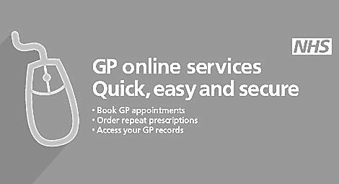
BOOK DONATIONS WANTED!
We would love your unwanted books! All donated books will be sold in surgery with all monies raised to be donated to St Teresa’s Hospice. Total money raised to date £450. Please help us to support this worthy cause.

