Results of Patient Survey 2012/13

Question 1: Is your GP Surgery currently open at times convenient for you?

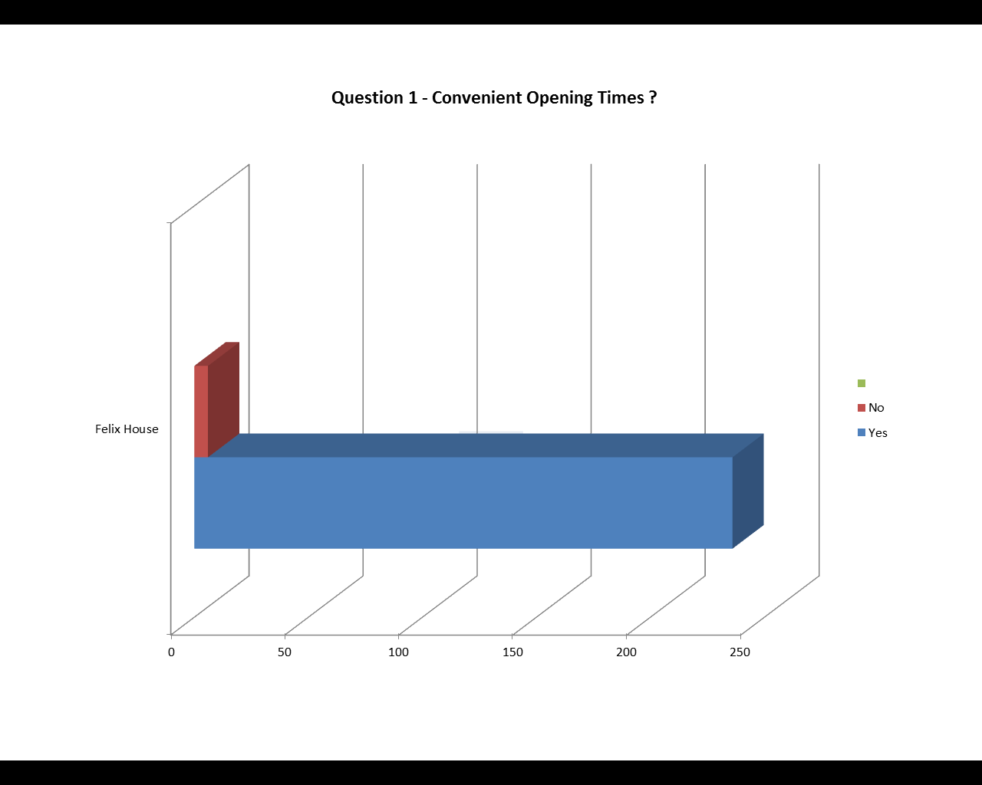

Question 2: How do you normally make your appointments?

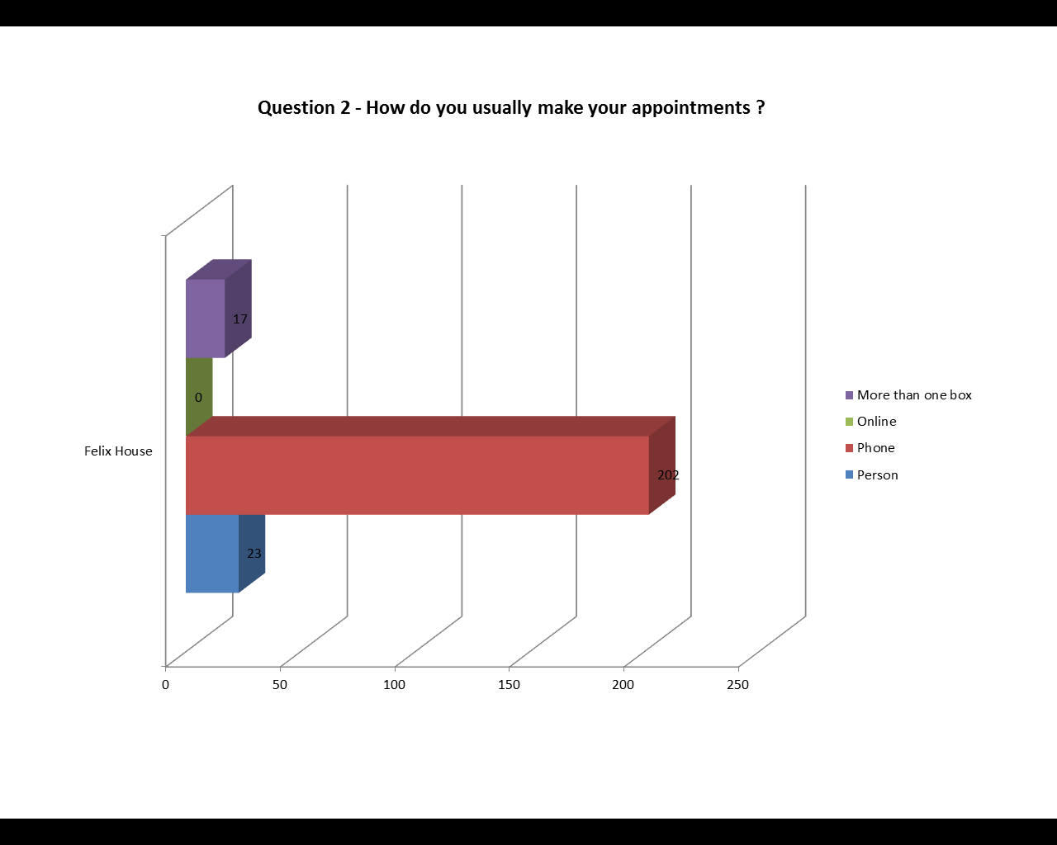

Question 3: How do you rate the experience of making appointments?

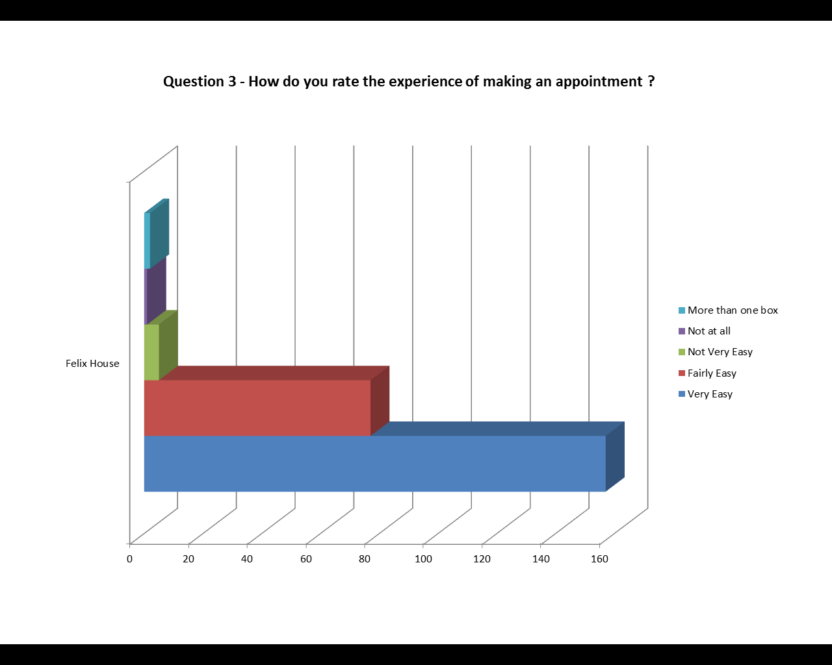

Question 4: Were you able to obtain an appointment within a reasonable time period of your request?

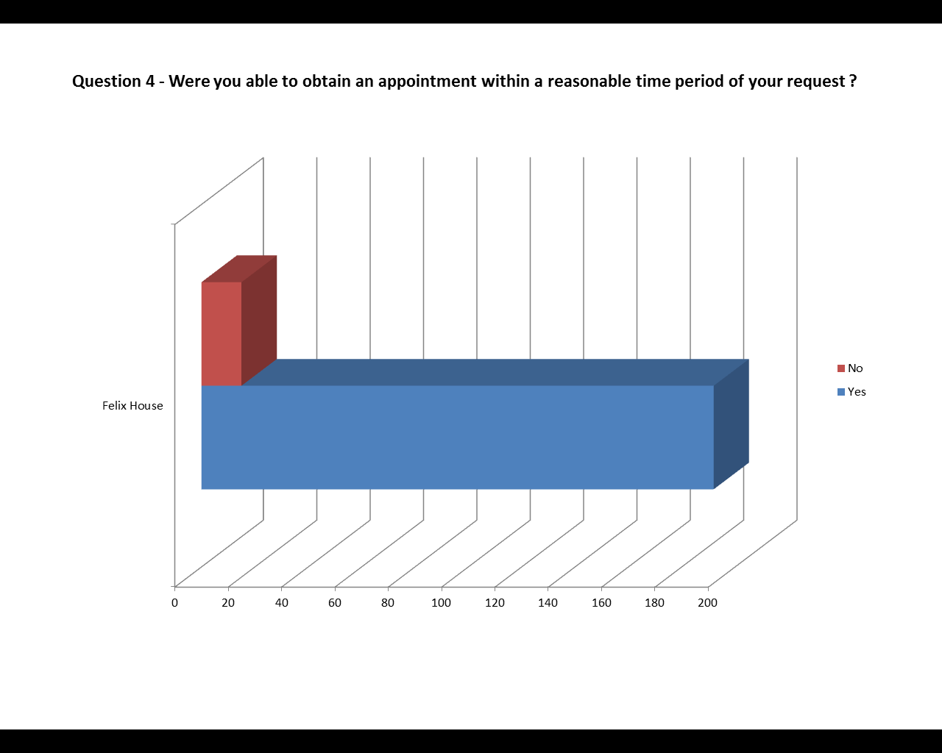

Question 5: How easy did you find the access into the surgery building?

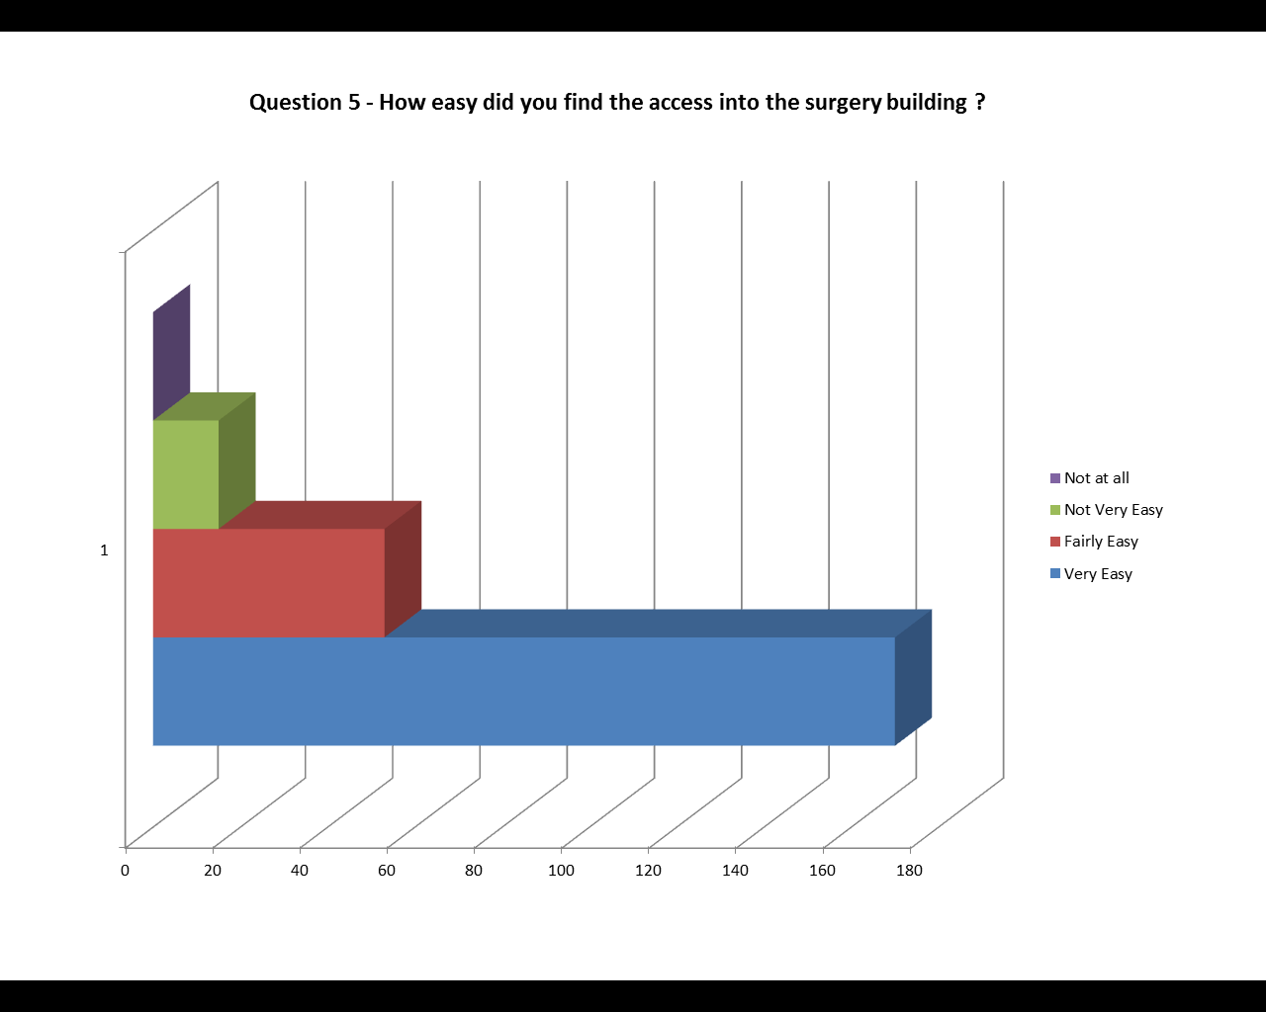

Question 6: How clean did you find your surgery?

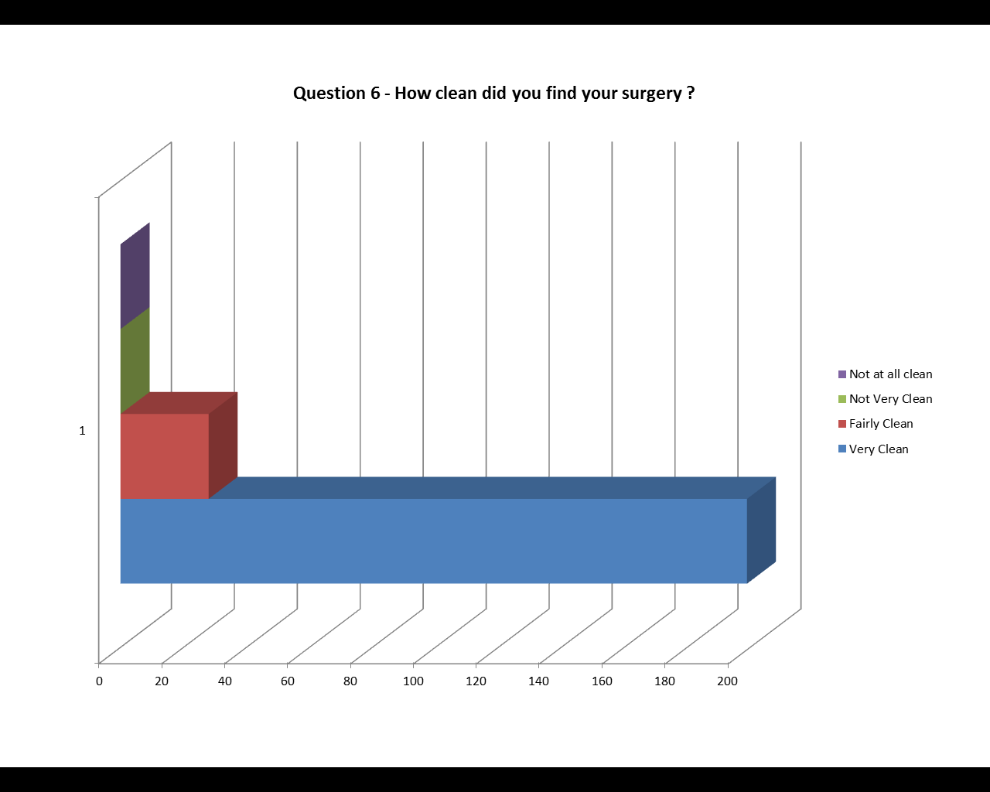

Question 7: How helpful did you find the reception team?

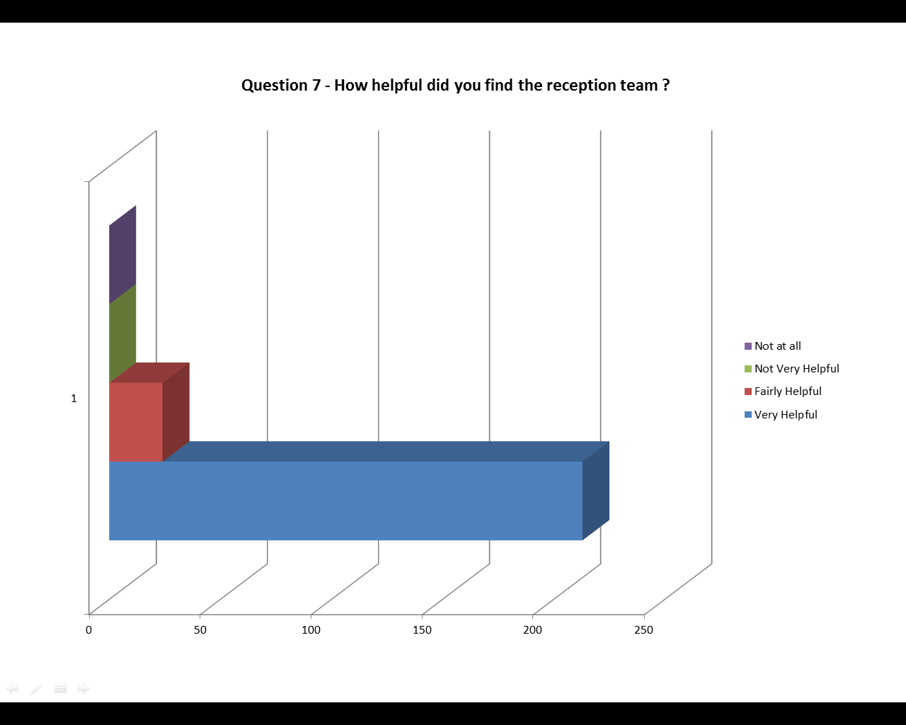

Question 8a: How long after your appointment time do you normally wait to be seen?

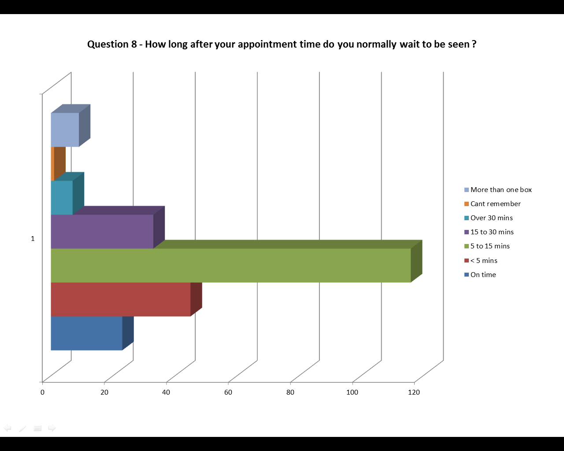

Question 8b: If you had to wait over 15 minutes, was an explanation given for the delay in being seen?

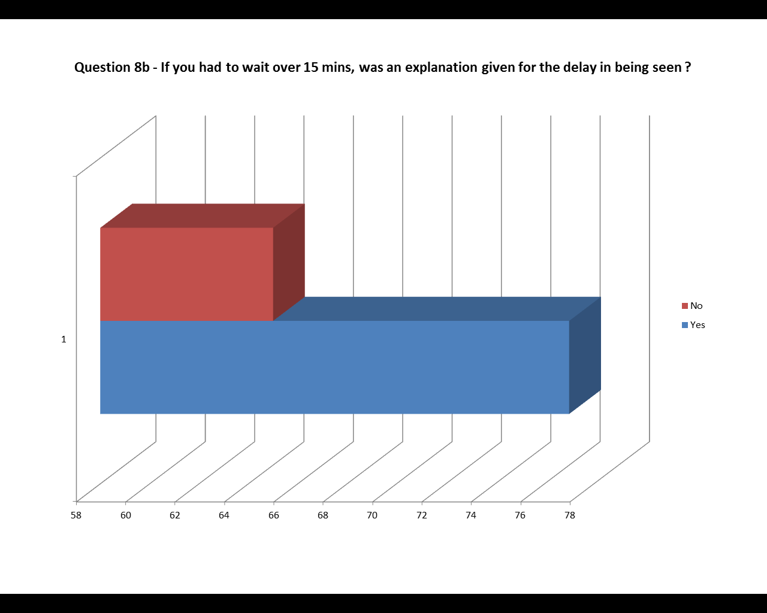

Question 9: How do you feel about how long you normally have to wait?

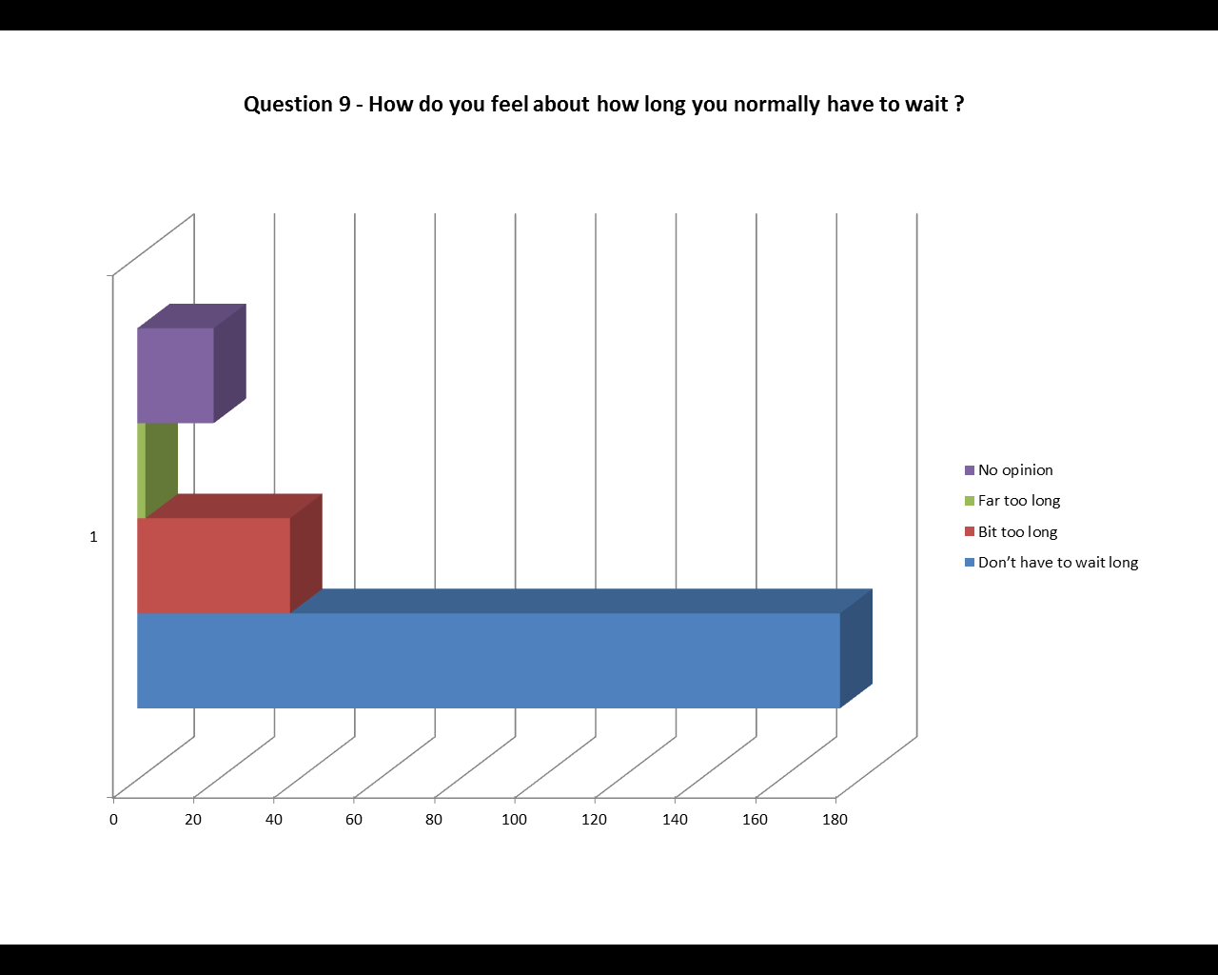

Question 10: The last time you saw a clinician (doctor/nurse/HCA) at the surgery, how good was the clinician at each of the following?

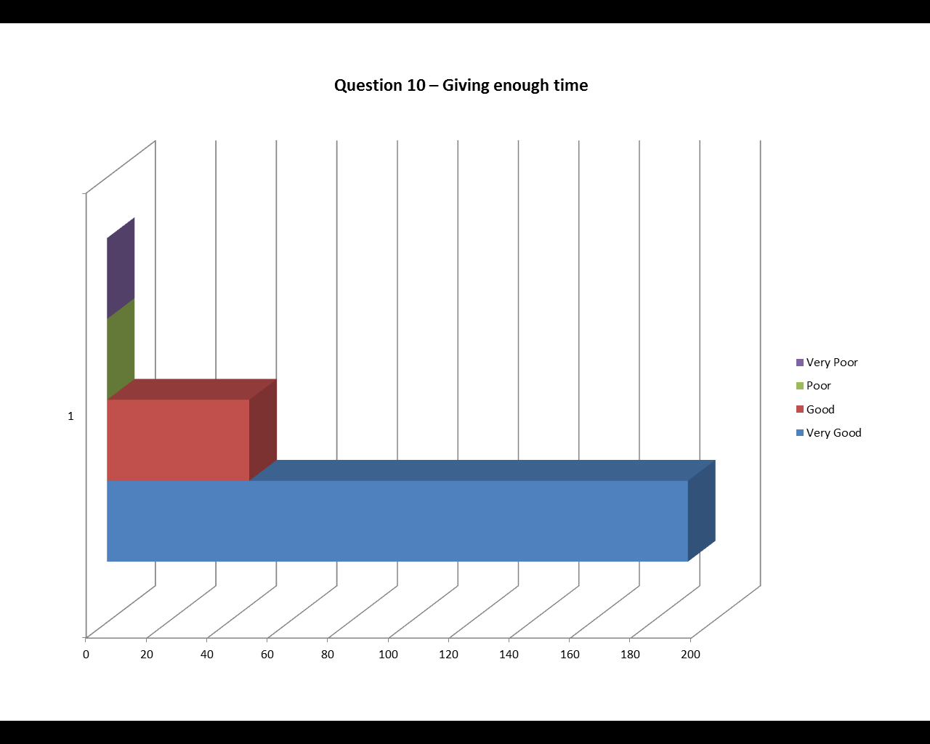
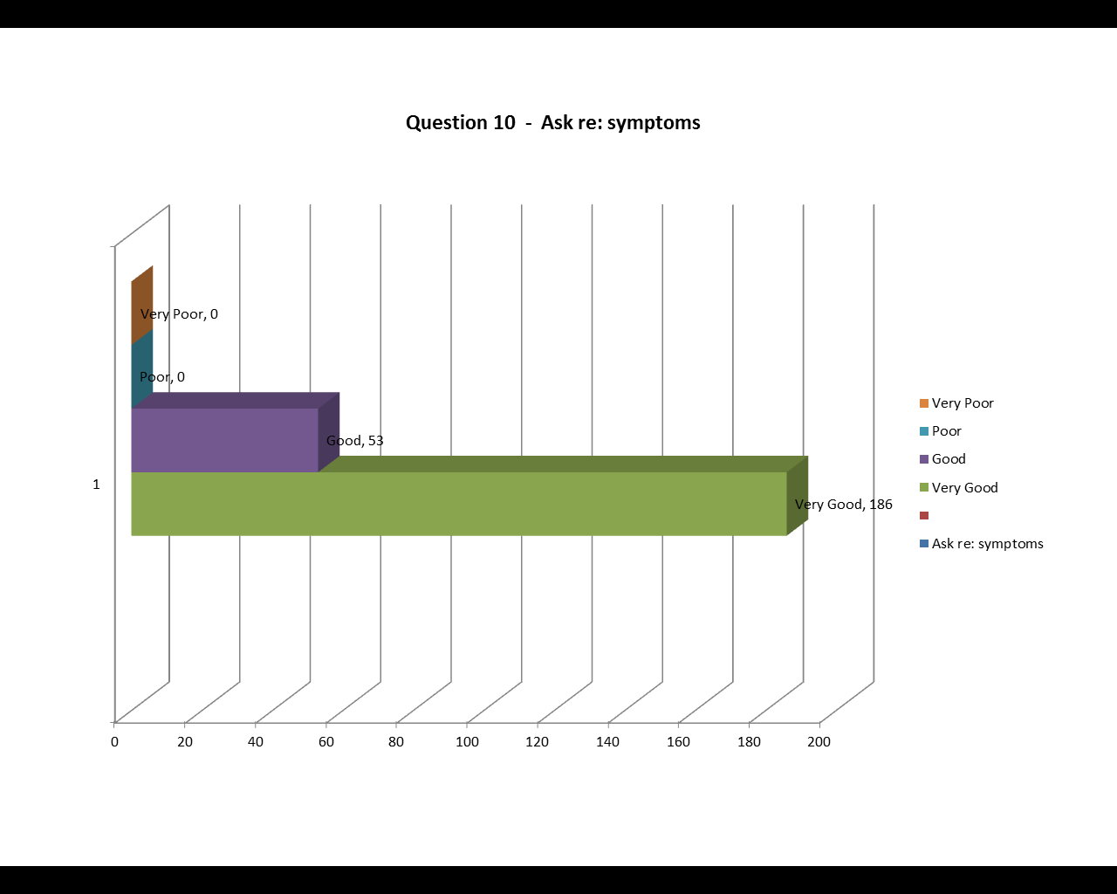
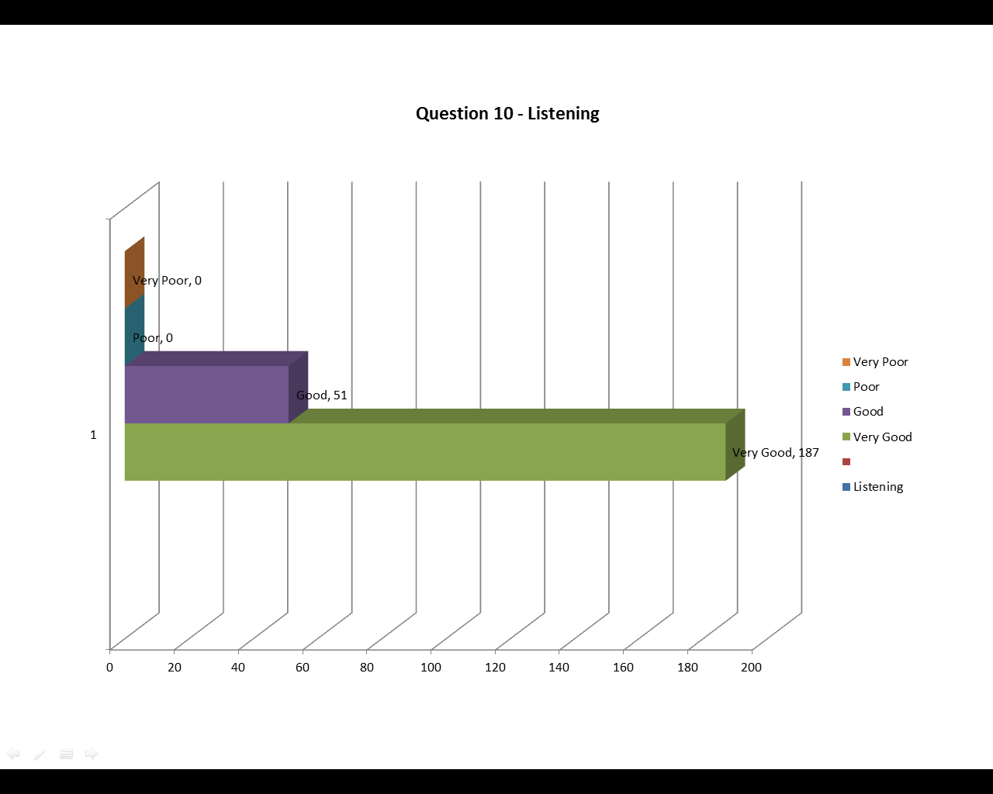
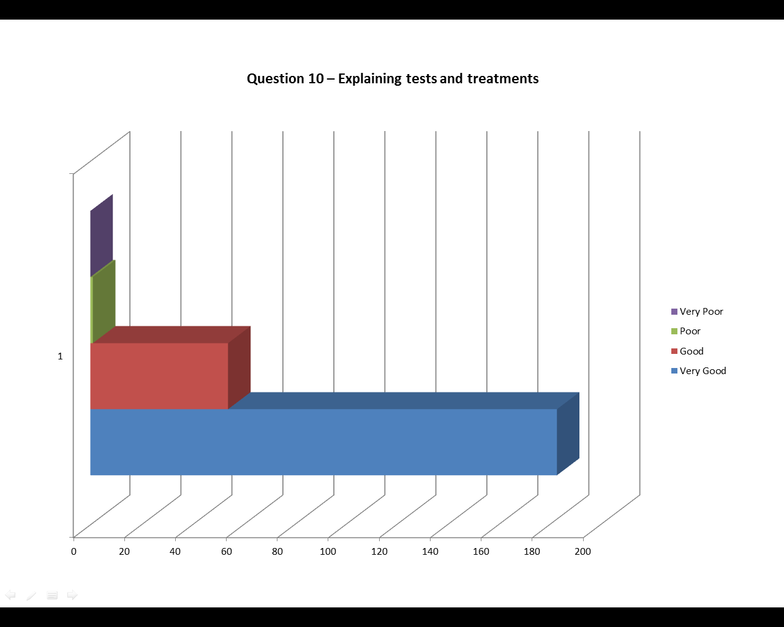
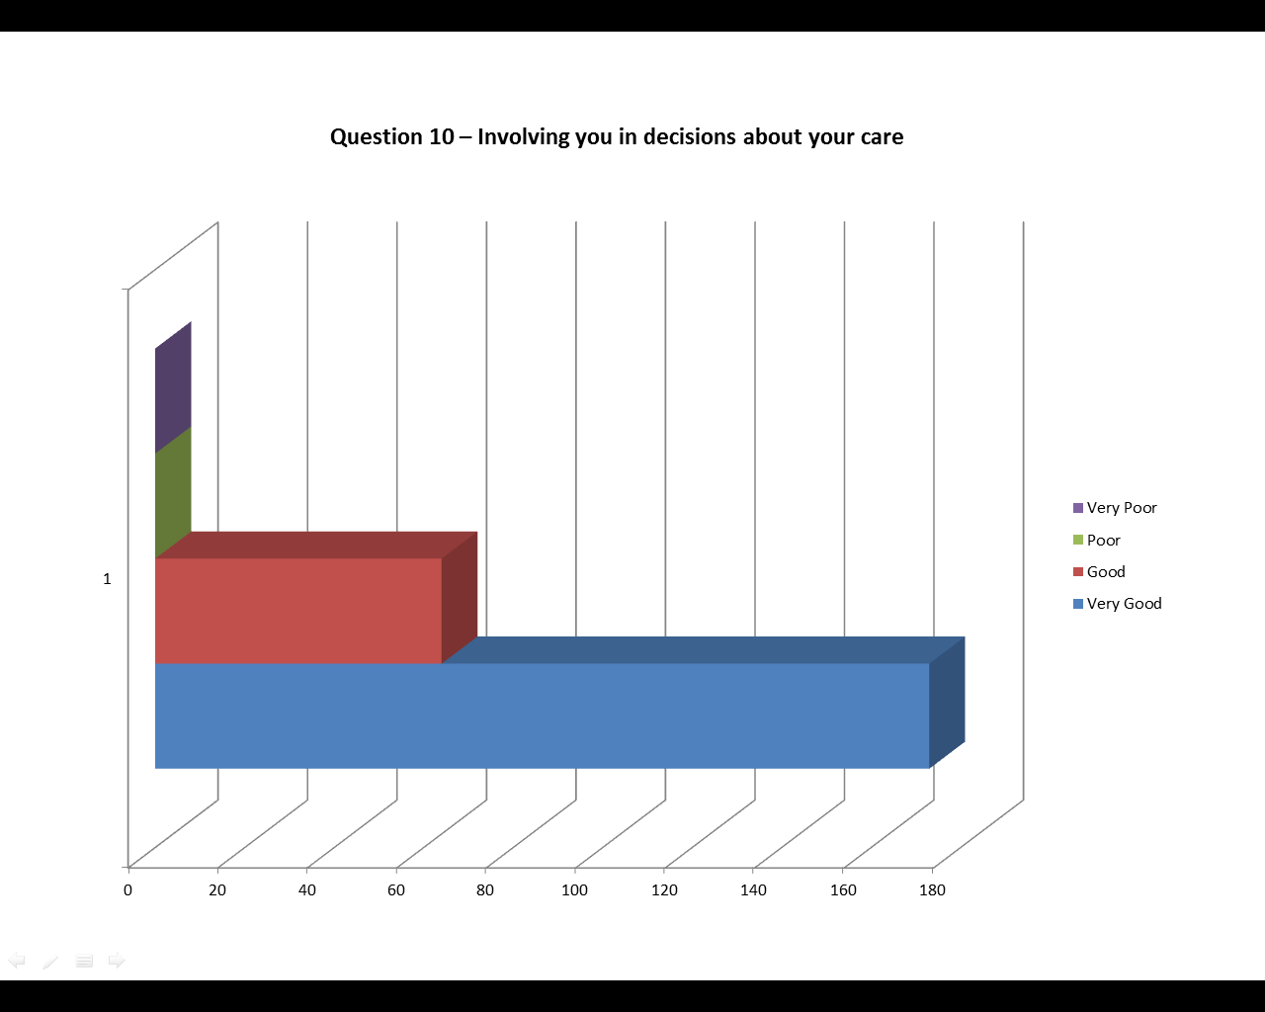
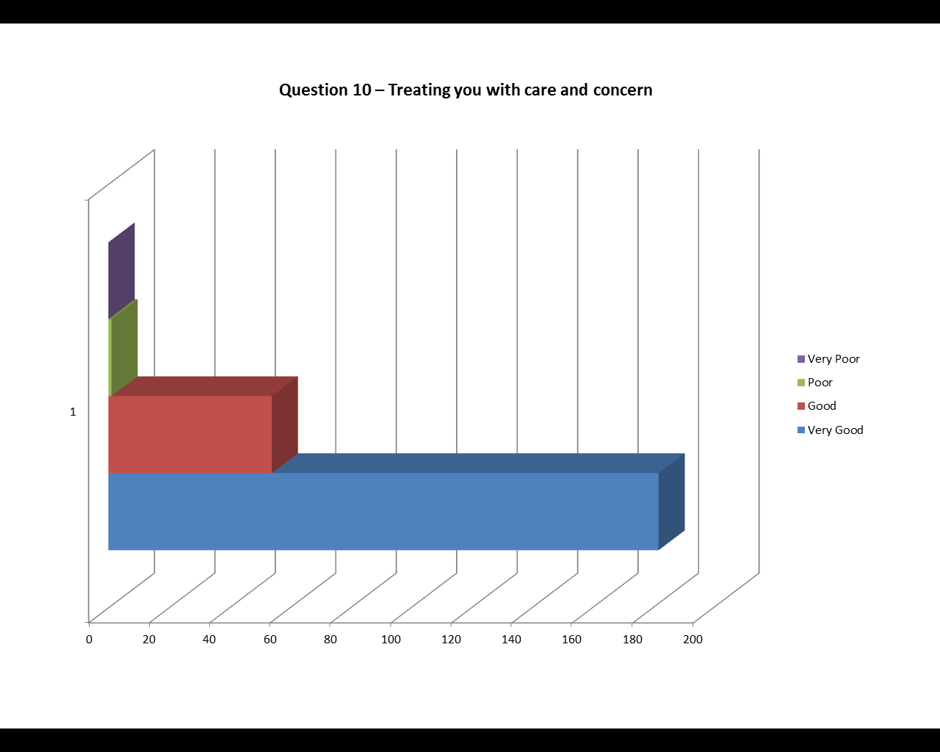
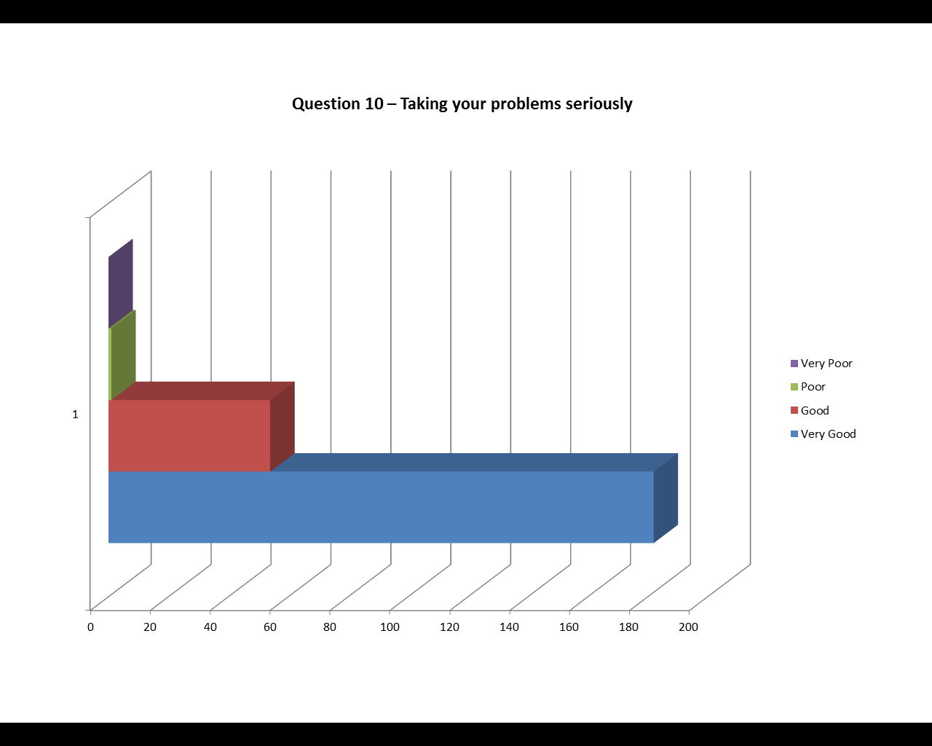
Question 11: Do you use the Surgery website, and if so do you have any suggestions on further information you would like to see on there?

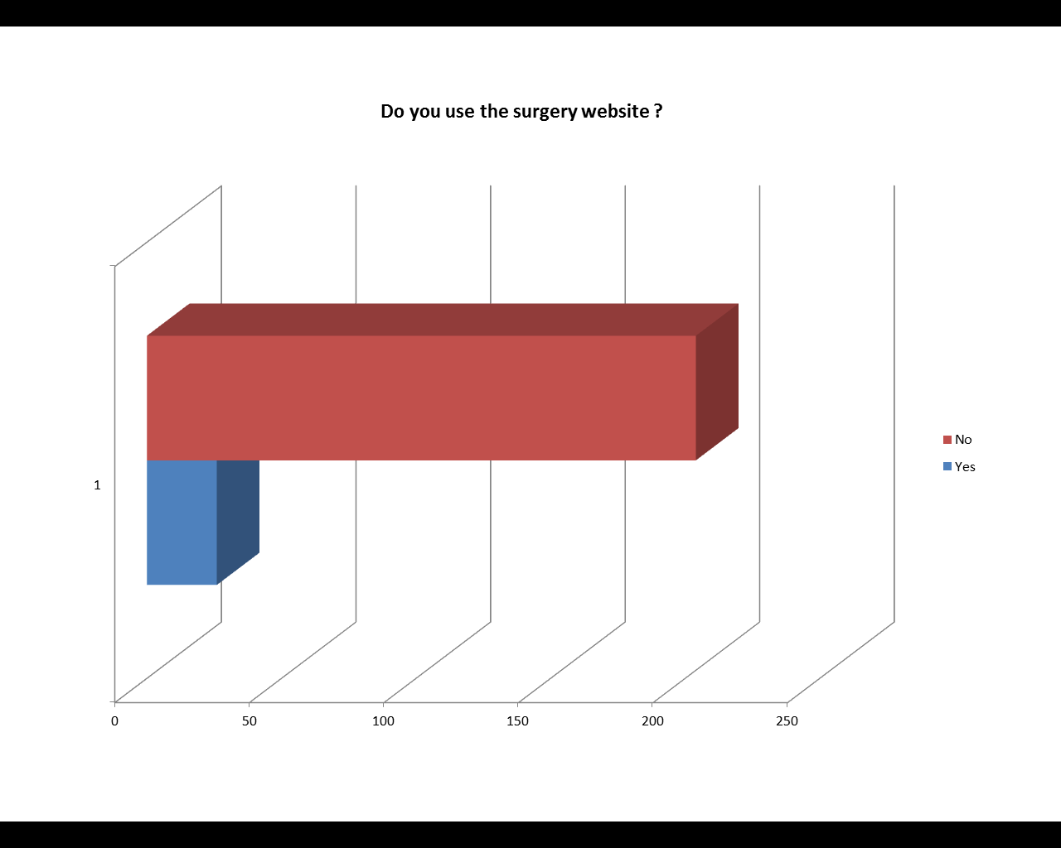

Question12: If we had an on-line booking system, would you use it? If not, please give a reason.

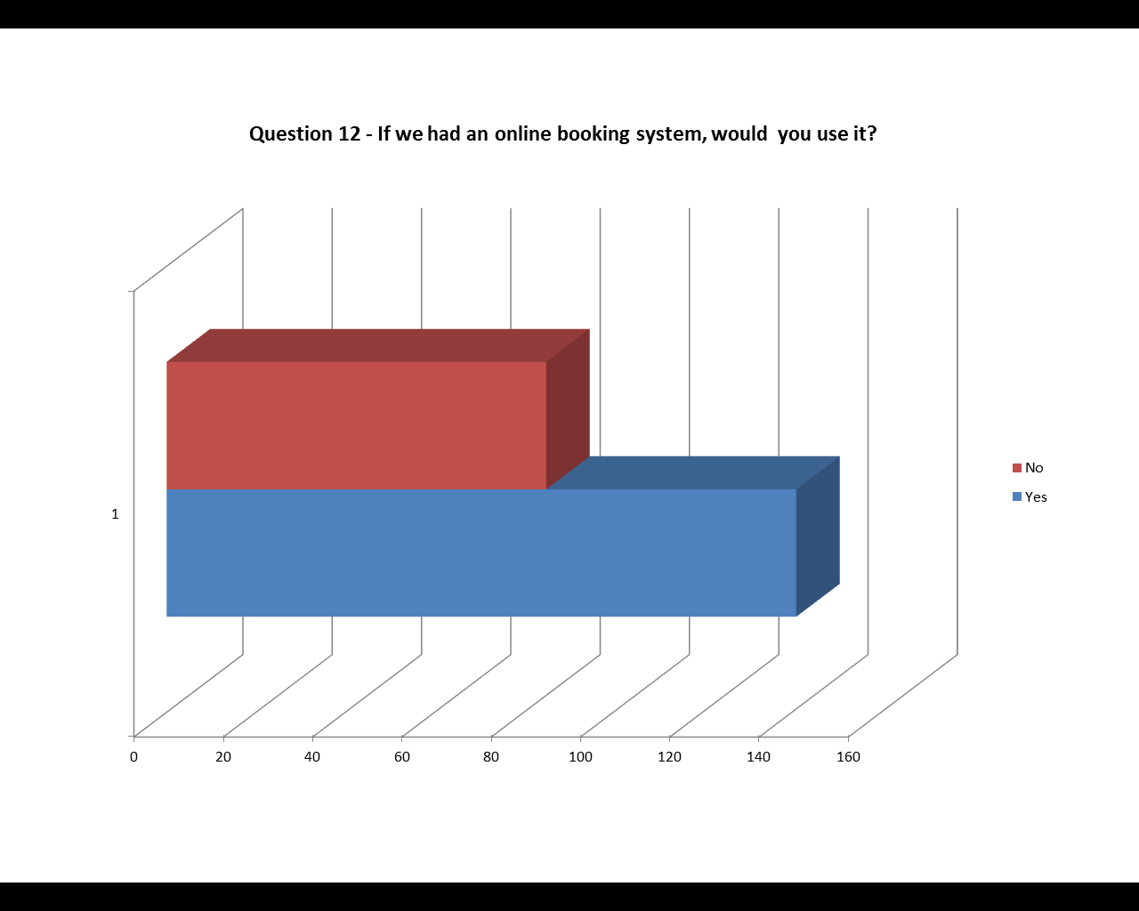
Question 14: Do you feel that you are given enough time to consider your consent?

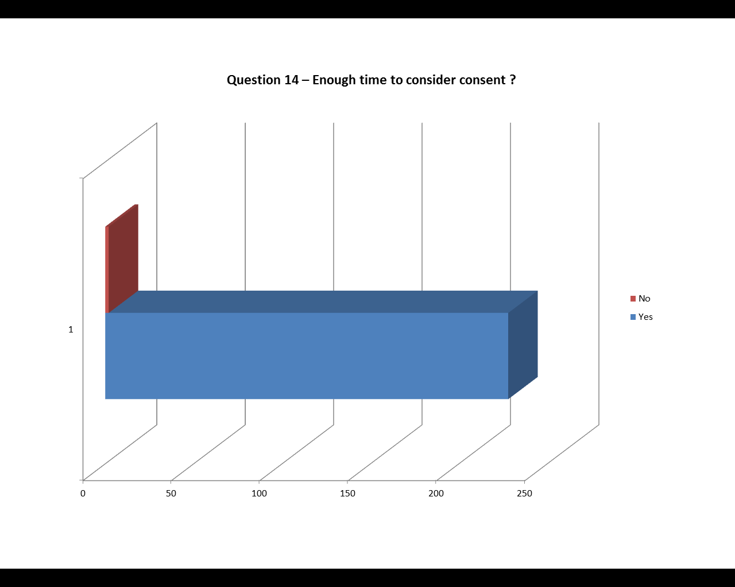

Question 15: Do you feel that you were given enough information and assistance to make a decision on consent?

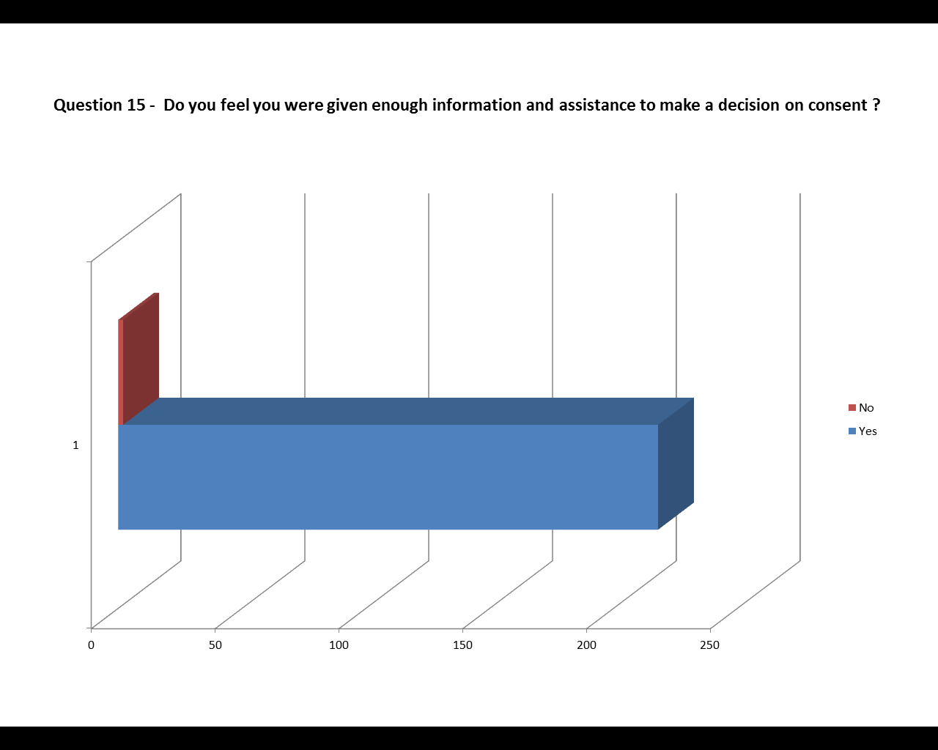

Question 16: Would you like a text message reminder of appointments?

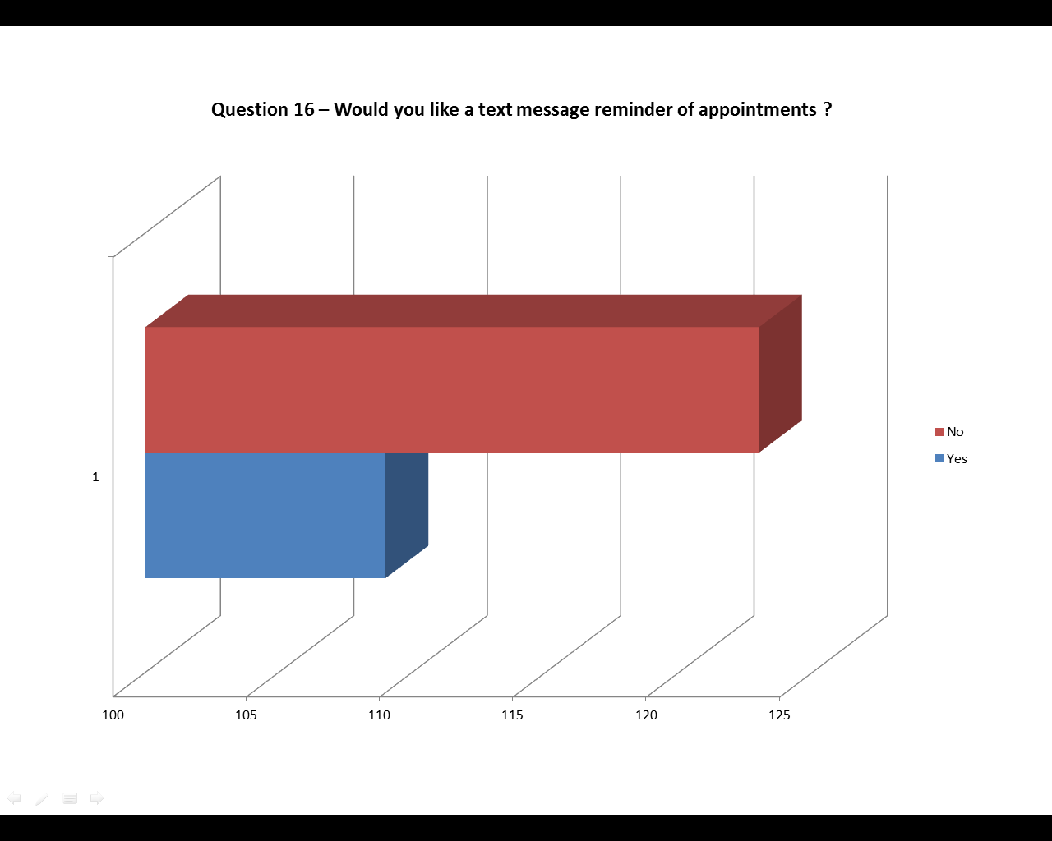

Question 17: If there was an alternative 01325 number would you use it, even though there could be a longer wait to get through to Reception?

