ST GEORGE’S MEDICAL PRACTICE
Yarm Road, Middleton St George, Darlington, DL2 1BY
Tel: 01325 332022
Website: www.stgeorgesmp.co.uk
Email: stgeorges.medical@nhs.net

Welcome to the Tenth edition of our newsletter from St George’s Medical Practice.
Surgery Closure
The Surgery will be closed for Staff Training on Wednesday 13th November and Thursday 12th December from 12pm and will reopen at 8am the following day.
Please note the surgery closes for staff training every Wednesday 12.30-2pm.

CHRISTMAS AND NEW YEAR OPENING TIMES
The surgery will be open on Christmas Eve – Tuesday 24th December as usual and will then close for the Christmas period and reopen on Friday 27th December at 8am. We will also be closed on New Years Day and reopen as normal on Thursday 2nd January 2020 at 8am.
NEW GP STARTING – 2ND JANUARY 2020
From 2nd January 2020 we will have a new female GP joining the practice, Dr Adisa. Some of you may already be familiar with her as she has been working in the practice over the summer period providing holiday cover.

FAILURE TO ATTEND
We average around 80 appointments every month where patients do not attend. If you are unable attend please respond to the reminder text with CANCEL or telephone the surgery as soon as possible on 01325 332022 so that we can offer your appointment to somebody else. Persistent failure to attends may result in a warning letter.
Have you had your flu vaccination?
You can now book your flu vaccine if you are aged 65 and over, have a chronic long-term health condition (those eligible will have been contacted by letter/text) or are aged between 2 and 3 years old.

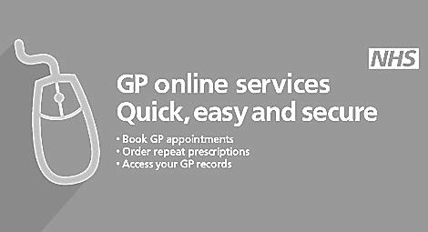
WE WISH YOU AND YOUR FAMILY A VERY MERRY CHRISTMAS AND A HAPPY NEW YEAR!

