ST GEORGE’S MEDICAL PRACTICE
Yarm Road, Middleton St George, Darlington, DL2 1BY
Tel: 01325 332022
Website: www.stgeorgesmp.co.uk
Email: stgeorges.medical@nhs.net

Welcome to the Eighth edition of our newsletter from St George’s Medical Practice.
Surgery Closure
The Surgery will be closed for Staff Training on Tuesday 16th July and Wednesday 14th August from 12pm and will reopen the following day at 8am. The surgery is also closed for the August Bank Holiday on Monday 26th August and will reopen on Tuesday 27th August at 8am.
Please note the surgery closes for staff training every Wednesday 12.30-2pm.

Care Navigation
Due to the unprecedented demand on GP’s in order to ensure that you are able to access the most appropriate care in the quickest time, on contacting the surgery you will now be asked a series of questions by the Medical Receptionist so that we are able to direct you to most appropriate care provider, as in some cases you may not need to see a GP in the first instance. There are a number of self-referral services available such as the Community Physiotherapy Service (any musculoskeletal/joint ache, pain or sprain), Minor Eye Conditions for example sticky eyes and Kooth for young people aged between 11 and 18 who are feeling anxious or worried. If you require medical advice, medical enquiry or require a sick note you may be asked to complete an e-consult form, accessed via the Practice’s website www.stgeorgesmp.co.uk (response by the end of the next working day) or offered a non-urgent telephone appointment.
MEASLES, MUMPS & RUBELLA (MMR) VACCINATION CATCH-UP
As you may have seen in the National news the number of cases of measles, mumps and rubella is on the rise due to a lack of uptake in the vaccine programme. Over the coming weeks you may receive a letter or text from the Practice asking you to make an appointment for the vaccine as our records may indicate that you have not completed the vaccine course. If you have any further questions or concerns please do not hesitate to contact us.

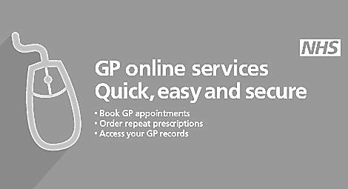
NHS APP
The NHS app is now available to be downloaded to your mobile phone. Once you have registered with the app you can book/cancel doctors appointments, review pending appointments, order repeat medication, view your medical record, access a online symptom checker and register for organ donation.

