ST GEORGE’S MEDICAL PRACTICE
Yarm Road, Middleton St George, Darlington, DL2 1BY
Tel: 01325 332022
Website: www.stgeorgesmp.co.uk
Email: stgeorges.medical@nhs.net

Welcome to the second edition of our newsletter from St George’s Medical Practice.
From 1st April 2018 we will be closed on Wednesday lunch times from 12:30 – 2pm.
From Monday 16th July 2018, Dr Patrick Holmes will have clinics on Monday’s as well as Thursday’s and Friday’s.
Friends and Family Test
All patients have the opportunity to state how likely they are to recommend our GP practice to friends and family. The information is used for quality monitoring purposes and is also fed back into the practice to enable changes and/or improvements to be made. The responses are anonymous and can be done via the paper copy in the waiting room or online via our website www.stgeorgesmp.co.uk.
We would like to thank everybody who has donated a book so far to the surgery in aid of St Teresa’s Hospice. Up to now we have raised £110 for the charity.
If you have any books you would like to donate, please drop them off at reception. Please also come and have a look at our selection of books in the waiting room – we are very grateful for your donations.

All members of staff at St George’s Medical Practice are required to attend essential monthly staff training, also known as protected learning time (PLT). The aim of these sessions is to develop knowledge and understanding in specific topics relating to general practice. Our next PLT is Thursday 12th July 2018. This means that the surgery will be closed from 12pm that day. We will re-open as normal on Friday 13th July 2018. We also have PLT in August which will be on Tuesday 14th August 2018 where again we will be closed from 12pm that day.
If you are aged 40 – 74 you could be eligible for a NHS Health Check. Please enquire at reception to find out if you are eligible and to book an appointment.
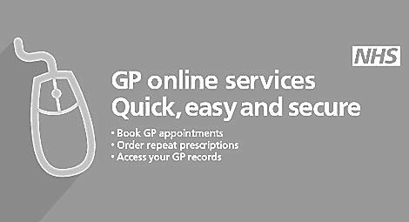
Just a reminder that Online Services are available within the practice to enable all patients to book and amend appointments, order repeat prescriptions and access personal medical records. Please enquire at reception to access this service.

